Aim: To Create a computerized version of a worksheet showing projected expenses for a University students' autumn term. The design of the worksheet is based on this hand-drawn planning version.
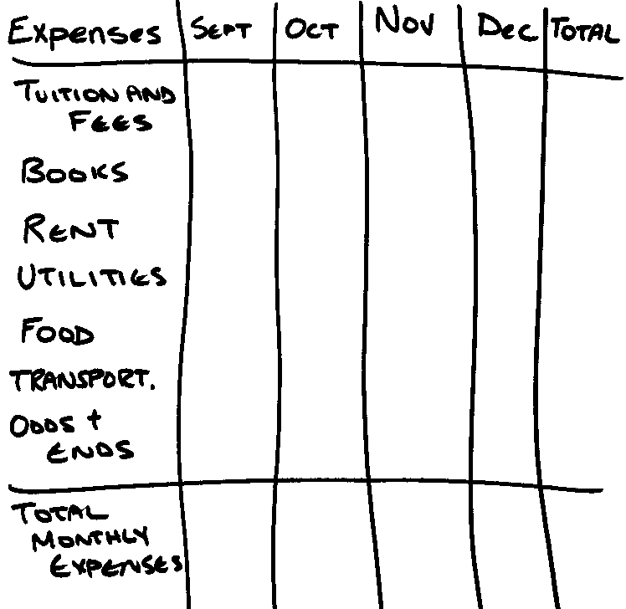

1) The first step is to launch MS Excel or Open Office Calc and start a new worksheet.
2) Next, type descriptive labels for the worksheet and TITLE, and label the rows and columns. You may have to adjust the column widths in order to accommodate some of the longer and shorter headings.
3) You should now also try to change the format of the cells to allow them to show the dollar sign figures (currency). Try using the shortcut method (right click) when you have the desired cells selected.
4) Now the data:
a) Tuition and fees were a one-time fee which you paid in September £3500)
b) Books were also a one-time fee, also paid in September. (£450)
c) Rent is a constant £250 a month, however you had to pay a £125 damage deposit in your first month.
d) Utilities are getting more expensive as the cold sets in. (Sept. £50, Oct. £60, Nov. £75, Dec. £95)
e) Food is a constant £160 a month.
f) Transportation is also a constant £120 a month.
g) Odds and ends have been £100 a month for the first three, however this increases in December by £300 for your Christmas shopping.

5) Once you have the data filled in, you need to calculate the totals for each month, as well as the totals for each row.
6) Once the formulas are entered, and totals are complete, you should format the worksheet to make it much more attractive. Change to suit your own tastes, however, keeping in mind that the worksheet will be read by others and should be readable.
7) You may send the worksheet to your lecturer at this point, or you may want to try the additional activity below.

Extension Activity : Creating Charts to accompany the worksheet.
1) Using the worksheet from the previous section, create a chart depicting the data entered in a graphical form,

Some Guidelines:
a) Highlight the data from the worksheet from which you wish to chart.
b) From insert, choose chart.
c) Choose a column chart
d) The column chart often looks best when the months lay on the horizontal axis (bottom). To do this choose "series: in rows"
e) The chart should be placed on the same page as your worksheet. Make sure the two do not overlap.
f) Save the resulting document on the VLE in Exercise 2

